End User Documentation

Section 1: General Systems Description and Critical Data

Hardware Specifications

|  | **List** | **Specifications** | **Notes** |
| --- | --- | --- | --- |
| **Turtlebot** | Dimensions (mm) (LxWxH) | Turtlebot3 & Launcher:  293x262x212 |  |
| Weight (kg) | Launcher: 0.924  Turtlebot: 1.51  Counter-weight: 0.2  Total weight: 2.634 |
| Wheel Base (mm) | 80.66 | From center of DYNAMIXEL to the center of ball caster |
| DC Motor | 2x JGB37-520 |  |
| Servo Motor | 2x SG90 |  |
| **Payload** | Dimensions (mm) (LxWxH) | 40 x 40 x 40 | Ping Pong Ball |
| Weight (kg) | Ping Pong: 0.0027  Total: 0.0243 | 9 Ping Pong Ball |
| **System** | Battery Capacity | 1800 mAh |  |
| Expected Operating Time | 92.3 min |  |
| Communication Interface | GPIO,PWM,I2C,UART,USB,TTL, TCP |  |

Instructions before start of mission

1. Put the balls in the pipe.
2. Set the servo to zero angle by the test code. (Keep the rack away from the pinion during this step).
3. Place the robot inside the maze and run the scripts.

Mission flow

1. The turtlebot navigates through the maze and creates a slam map using lidar points along with frontier exploration.
2. It simultaneously looks for heat sources using the AMG8833 sensor.
3. If the temperature measured exceeds the threshold value, the balls are fired.
4. The above steps are again repeated.

Section 2: Technical Guide

Electronic Architecture Diagram

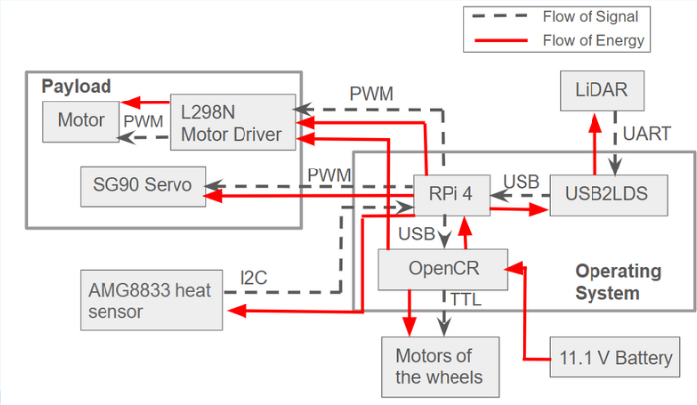

Mechanical Assembly Instructions

| Item No. | Qty | Part Name |  |
| --- | --- | --- | --- |
| 1 | 1 | S90 servo for heat sensor |
| 2 | 1 | IR sensor |
| 3 | 1 | Ball holder |
| 4 | 2 | Flywheel motor |
| 5 | 2 | Flywheel |
| 6 | 1 | S90 servo for rack and pinion |
| 7 | 1 | Rack and pinion |
| 8 | 1 | Pipe support |
| 9 | 1 | Sensor servo holder |
| 10 | 1 | Acrylic Holder for Launcher |
| 11 | 1 | Weight |
| 12 | 1 | Turtlebot3 burger |  |

Section 3: Acceptance Defect Log

| Defect | Rectification | Defect Classification | | |
| --- | --- | --- | --- | --- |
| Critical | Major | Minor |
| The rubber grip on the flywheels may spoil over a long time. | Replace the rubber grip. |  |  | x |

Section 4: Factory Acceptance Test

| Component | To be checked | Observation |
| --- | --- | --- |
| OpenCR | Able to be powered by the LiPo Battery | Green LED lights up when connected to a power source, boot up tune being played |
| RPi | Able to turn on the RPi when connected to OpenCR | Red light turns on while green light flashes |
| Can be connected to from the remote laptop | Terminal returns “Welcome to Ubuntu…” when “ssh ubuntu@<ip-address>” is run on terminal |
| RPi is able to connect to the network (Wi-Fi) | RPi appears in the hotspot’s connected devices list |
| LiDAR | Able to spin and collect data consistently | Environment will be mapped on Rviz with slam toolbox |
| SG90 (1) | Able to rotate the rack and pinion to feed payload into flywheels | Platform goes up and down launcher tube smoothly |
| SG90+AMG8833 sensor | Able to scan for the heat sources | The sensor prints an 8x8 array of temperature when the test code is run |
| JGB37-520 x2  (Flywheel motors) | Able to shoot the ball above the wall | The flywheel shoots the ball when the test code is run. |
| Wheels | Able to move the bot in all directions freely. | Bot can be controlled properly when running ‘rteleop’ |
| Ball caster | Able to roll in all directions freely. | Bot able to move around in all direction smoothly with ball caster attached |
| Structural Stability | Structural platforms and components installed correctly | Shake Turtlebot to verify all components are mounted securely |
| Verify all fasteners installed and tightened | Verify fastener count are consistent with assembly document |

Section 5: Maintenance and Part Replacement Log

| Log No. | Defect Date | Qty | Defect Component | Problem Description | Rectification | Close Date |
| --- | --- | --- | --- | --- | --- | --- |
| 1. | 1 April 2024 | 1 | SG90 servo motor | The servo was burnt as it was supplied 5 V instead of 3.3 V | The servo motor was replaced. | 1 April 2024 |